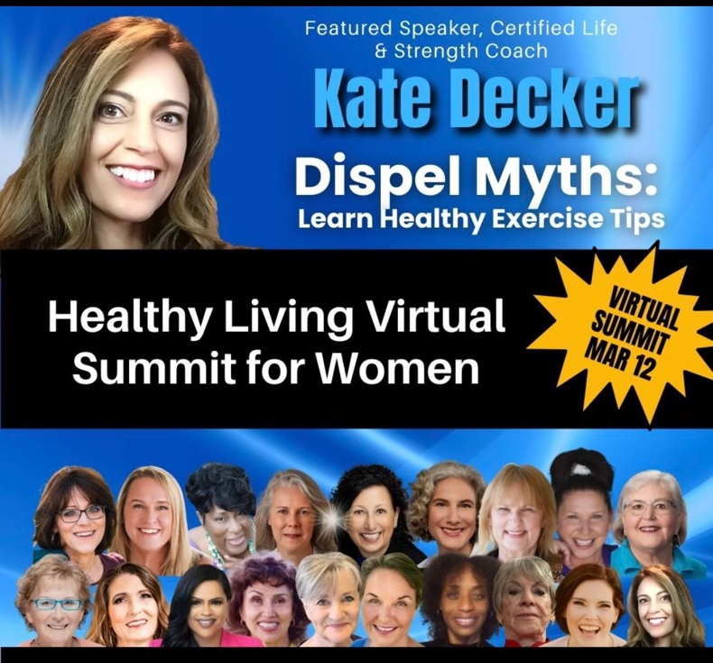

Thank you for joining me on the
Healthy Living Summit, March 12!

Whether you eat or drink or whatever you do, do it for the glory of God!!
1 Corinthians 10:31

You and your health are important. You are a blessing and a gift from God. God has given you unique talents unlike others. Taking care of yourself and the magnificent body, spirit, and mind that God has given you is essential. Sometimes it is easy to forget oneself amid hectic lives, but taking time for yourself and the renewal of your health shouldn’t just be a vacation time mindset it should be an everyday occurrence.

If you are someone who places others’ needs before your own remember if you don’t take care of yourself, it will be hard at some point to take care of others as well.

Here are some pointers I share with my online and in-person clients. Hope you enjoy. If we can be of further assistance, please feel free to reach out.

Yours in health,

Kate Decker, Founder
Founder of Institute of Athletic Movement
Featured Speaker, Christian Women’s Speakers
Decker@Iam4health.com
“Dispelling Myths and Learning Healthy Exercise Tips”
Healthy Living Summit

- Is there such a thing as too much exercise?
- Yes. There is substantial research showing that overuse or overtraining can place an individual at greater risk for certain injuries.
- Being a multi-sport athlete has many advantages in fact it is a top consideration for college recruiters when they consider offering an athlete a spot on the team, however playing more than one sport at the same time or playing the same sport for multiple teams at once may increase risk of certain potential injuries.
- Is form/technique important?
- Yes! If you are doing too many sets and reps where your form starts to fail, this may place you at a higher risk for certain injuries and you may not receive as great a benefit from the exercises you are doing.
- Learning correct technique from the beginning can, depending on the exercise, increase overall strength and speed and motor skills. This strong foundation can then be built upon to learn more complex movement patterns and exercises.
- Technique and balance of exercises are equally important. Many individuals with whom we have worked focus on programs that may overwork the front of the shoulder or chest and not spend enough time on the posterior shoulder or back. With typical neck and back positions on devices like phones and computers the back of the body such as back and hamstrings should be balanced as a rule of thumb more than the front. One method we use based on exercise science is a 2 to the posterior chain for every 1 to the anterior chain ratio. For example if you are doing 3 sets x 5 reps on bench then supplementing it with 4x5 bent rows and 2x5 reverse flies can be helpful.
- I don’t have enough time. This is a comment we hear frequently, so how do we change this consideration?
- Choose to set this priority of exercise on your schedule. 15-20 minutes of cardio and or corrective exercise is a step in the right direction. 30 minutes is even better, but choosing to start is a giant step for which you should be proud.
- Have an accountability partner. Working out with friends has many advantages. It’s fun, you are less likely to bail on your workout, and you have the blessing of being with someone you care about and who cares about you which is great for the mind and body!!

- What can I do to help my posture?
- Try to change your positions throughout the day. If you have a job, where are you are sitting frequently try standing more throughout the day, or standing up and walking away from your desk and coming back. Taking time to move is beneficial. You may also consider a standing desk or if you have good balance, a physio chair could be of interest.
- Corrective exercises like neck turtles, neck extensions, wall, postures, as mentioned in the Healthy Living Summit talk with correct technique can be helpful if included throughout the day.
- Sitting with your hips back in an ergonomically correct chair with your feet planted firmly on the ground can have a positive effect to the rest of your body providing a better spinal position.
- Avoid crossing your legs. If you notice them crossed with for example your right over left, then switch them up to even yourself out. Then start the habit of sitting without your legs crossed or consider crossing at the ankles.
- Face the person with whom you are talking. Constant rotation may put unnecessary stress on certain areas of one’s body.
These are just a few tips to get you started. Wishing you blessings in your quest for greater health.
God’s blessings and well wishes, Kate Decker

